Health Bot: A console based disease awareness Chatbot

Mini Project I
Submitted by

AMIRTHAMOZHI V S
24CSR019

ASMA THASNIM H
24CSR029

DHARANEESH S C

24CSR057
in partial fulfilment of the requirements for the award of the degree
of

BACHELOR OF ENGINEERING
IN
COMPUTER SCIENCE AND ENGINEERING

KONGU ENGINEERING COLLEGE
(Autonomous)
PERUNDURAI ERODE – 638 060

NOVEMBER 2025

DEPARTMENT OF COMPUTER SCIENCE AND ENGINEERING KONGU ENGINEERING COLLEGE
(Autonomous) PERUNDURAI ERODE – 638 060
November 2025

BONAFIDE CERTIFICATE

This is to certify that the Project report entitled Health Bot: A console based disease awareness Chatbot is the bonafide record of the project work done by AMIRTHAMOZHI V S (Register No: 24CSR019), ASMA THASNIM H (Register No: 24CSR029), DHARANEESH S C (Register No :24CSR057), in partial fulfillment of the requirements for the award of the Degree of Bachelor of Engineering in Computer Science and Engineering of Anna University Chennai during the year 2025-2026.

SUPERVISOR HEAD OF THE DEPARTMENT
Date: (Signature with seal)

KONGU ENGINEERING COLLEGE
(Autonomous)

PERUNDURAI ERODE – 638 060
NOVEMBER 2025

DECLARATION

We affirm that the Project Report titled Health Bot: A console based disease awareness Chatbot being submitted in partial fulfillment of the requirements for the award of Bachelor of Engineering is the original work carried out by us. It has not formed the part of any other project report or dissertation on the basis of which a degree or award was conferred on an earlier occasion this or any other candidate.
Date: AMIRTHAMOZHI V S
(24CSR019)

ASMA THASNIM H
(24CSR029)

DHARANEESH S C
(24CSR057)

I certify that the declaration made by the above candidates is true to the best of my knowledge.

Date: Name and Signature of the Supervisor

ACKNOWLEDGEMENT

We express our sincere thanks and gratitude to Thiru. E.R.K.KRISHNAN M.Com., our beloved Correspondent, and all other philanthropic trust members of Kongu Vellalar Institute of Technology Trust who have always encouraged us in academic and co-curricular activities.

We are extremely thankful with no words of a formal nature to the dynamic Principal Dr. R. PARAMESHWARAN M.E., Ph.D., for providing the necessary facilities to complete our work.

We would like to express our sincere gratitude to our respected Head of the Department Dr. S. MALLIGA, M.E., Ph.D., for providing the necessary facilities.

We extend our thanks to Ms. P. Santhiya Assistant Professor, Computer Science Engineering, Project Coordinator for her encouragement and valuable advice that made us carry out the project work successfully.

We extend our gratitude to our Supervisor Dr. N. SHANTHI Professor of Computer Science Engineering, for her valuable ideas and suggestions, which have been very helpful in the project. We are grateful to all the faculty members of the Computer Science and Engineering Department, for their support.

TABLE OF CONTENTS

CHAPTER No. | TITLE | PAGE No.
 | ABSTRACT  LIST OF ABBREVIATIONS | VI  VII

- INTRODUCTION 1
1.1 OBJECTIVE 1
1.2 SCOPE 1
- SOFTWARE REQUIREMENTS SPECIFICATION 3
  - SOFTWARE REQUIREMENTS 3
  - JAVA AND DATA STRUCTURES USED 3
- MODULE DESIGN 5
  - DESCRIPTION OF MODULES
- DATABASE DESIGN 7
- CONCLUSION 8
APPENDIX 9
APPENDIX 2 37
REFERENCES 40

ABSTRACT

This project focuses on developing a symptom-based disease prediction chatbot aimed at improving accessibility to preliminary health screening. Many individuals lack immediate access to medical professionals or basic health awareness, especially in rural or underserved areas. The chatbot addresses this gap by offering a conversational interface that guides users through a series of health-related questions to help identify potential illnesses based on their symptoms.

The chatbot is built using Java for its core logic and MySQL for backend data storage. It interacts with users via a command-line interface, asking ten randomly selected symptom-related questions. User responses (y, n, or bye) are validated and matched against a structured database containing diseases and their associated symptoms. The system uses rule-based logic to calculate the match percentage and predict the most relevant disease. JDBC is used to connect the Java application to the MySQL database, ensuring smooth data retrieval and processing.
After collecting user responses, the chatbot evaluates all possible diseases and displays the top match along with an accuracy score, calculated based on the proportion of matched symptoms. This lightweight diagnostic tool demonstrates how simple logic and database integration can provide meaningful health insights. It lays the foundation for future enhancements such as machine learning-based predictions, multilingual support, and integration with real-time medical data, making it a scalable solution for digital healthcare applications.

LIST OF ABBREVIATIONS

- CLI – Command Line Interface
- DB – Database
- IDE – Integrated Development Environment
- JDBC – Java Database Connectivity
- JDK – Java Development Kit
- SE – Standard Edition (Java SE)
- SQL – Structured Query Language
- UI – User Interface

CHAPTER 1 INTRODUCTION
The Smart Health ChatBot is a Java-based application designed to assist users in identifying potential health conditions based on their symptoms. By interacting through a simple command-line interface, users respond to a series of symptom-related questions. The system then analyzes these responses and matches them with a database of known diseases using structured queries via MySQL. The chatbot predicts the most likely disease and provides a brief description, offering users a preliminary understanding of their condition. This tool is especially useful for individuals with limited access to healthcare, serving as an educational and awareness platform.
  - SCOPE
The scope of the Smart Health ChatBot project is to develop an interactive, symptom-based diagnostic assistant that helps users identify potential health conditions through a conversational interface. The system is designed to ask users a series of symptom-related questions, validate their responses, and predict the most likely disease based on a curated database. It also provides a brief description of the predicted disease to enhance user understanding. The chatbot is intended to be lightweight, user-friendly, and accessible to individuals with limited medical knowledge or access to healthcare services. It supports basic input formats and can be deployed in educational, rural, or personal health awareness settings.
  - OBJECTIVE
The objective of the Smart Health ChatBot project is to create an interactive system that helps users identify potential health conditions based on their symptoms through a simple and conversational interface. The chatbot is designed to ask users a series of symptom-related questions, validate their responses, and match them with a curated database to predict the most likely disease. It also provides a brief description of the predicted condition to enhance user understanding. The system aims to be user-friendly, accessible to individuals with limited medical knowledge, and useful in environments where professional healthcare may not be immediately available. By offering a quick and intuitive way to assess symptoms, the chatbot empowers users to make informed decisions about their health and seek timely medical attention when necessary.

CHAPTER 2

SOFTWARE REQUIREMENT SPECFICATIONS

SOFTWARE REQUIREMENTS

2.1.1 Java SE (Standard Edition)
- Used to build the core chatbot logic.
- Provides essential libraries like Scanner, ArrayList, and control structures.

JDK (Java Development Kit)
- Required to compile and execute Java programs.
- Includes the Java compiler (javac) and runtime environment (java).

VS Code IDE
- Used as the development environment for writing and debugging Java code.
- Offers extensions for Java and MySQL integration.

MySQL Server
- Stores structured data including symptoms, diseases, and descriptions.
- Enables efficient querying and data management.

JDBC (Java Database Connectivity)
- Connects the Java application to the MySQL database.
- Facilitates data retrieval and updates during chatbot execution.

JAVA AND DATA STRUCTURES USED
- Scanner Class: Used to read user input from the command line interface.
- Conditional Statements (if, else): Applied to control the chatbot's decision-making based on user responses.
- Loops (for, while): Used to iterate through symptom questions and process multiple inputs.
- Methods: Helped modularize the code for tasks like asking questions, matching diseases, and displaying results.
- JDBC (Java Database Connectivity): Enabled communication between the Java application and the MySQL database.
- ArrayList: Used to dynamically store symptoms selected by the user.
- HashMap: Mapped diseases to their associated symptoms and supported accuracy calculations.
- String: Handled user inputs, symptom names, and disease descriptions.
- Integer/Double: Used for calculating and displaying the accuracy percentage.
- Arrays: Stored lists of symptoms or diseases retrieved from the database.

CHAPTER 3

MODULE DESIGN

3.1 DESIGN OF MODULES

Handles user input and output through the command line. It starts the conversation when the user enters the choice and ends it when the user says exit.
Fig 3.1 illustrates the chatbot's interaction process: the user starts by typing "hi", triggering symptom-related questions. Based on the user's yes/no responses, the chatbot either ends the session or displays the predicted disease result.
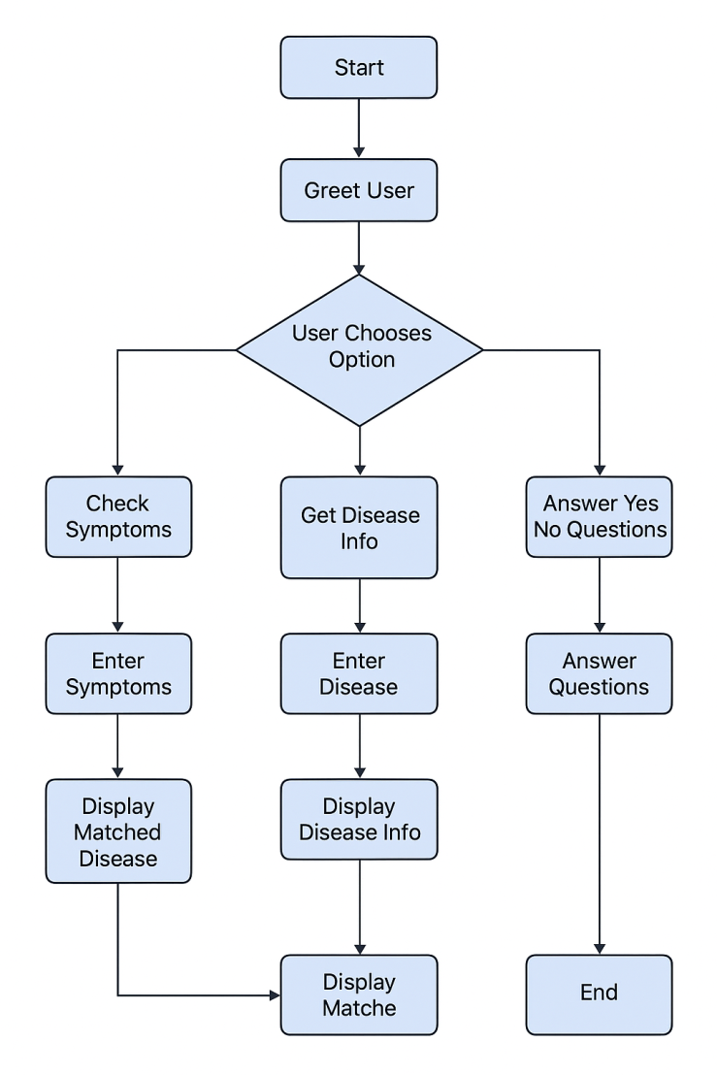

FIGURE 3.1 FLOWCHART

SYMPTOM CHECKER MODULE

This module asks the user a series of symptom-related questions. Validates responses (y, n, bye) and collects selected symptoms for analysis.

DISEASE MATCHING MODULE

It functions as matching the user's symptoms with diseases stored in the database. Calculates match percentage and identifies the most likely disease.

DISEASE DESCRIPTION MODULE

Here, this module retrieves and displays a brief description of the predicted disease to help the user understand the condition.

INPUT VALIDATION MODULE

Input validation module ensures that user inputs are valid and within expected formats. Prevents errors due to incorrect or unexpected responses.

DATABASE CONNECTION MODULE

This module establishes and manages the connection between the Java application and the MySQL database using JDBC.

SYMPTOM – DISEASE MAPPING MODULE
It handles the retrieval of symptom-disease relationships from the database. Counts total symptoms per disease and supports matching logic.

DISEASE INFO RETRIVAL MODULE
This module is used to fetches additional details about diseases from the database, such as descriptions, and prepares them for display in the chatbot.

CHAPTER 4

DATABASE DESIGN

Table Name | Field Name | Data Type | Key Type | Purpose
disease | disease_id | INT | Primary Key | Unique ID for each disease
 | disease_name | VARCHAR | — | Name of the disease
 | description | TEXT | — | Description of the disease
symptom | symptom_id | INT | Primary Key | Unique ID for each symptom
 | symptom_name | VARCHAR | — | Name of the symptom
disease_symptom | id | INT | Primary Key | Unique ID for each mapping entry
 | disease_id | INT | Foreign Key | Links to  disease.disease_id
 | symptom_id | INT | Foreign Key | Links to symptom.symptom_id

CHAPTER 5

CONCLUSION
The Smart Health ChatBot project successfully demonstrates how technology can be leveraged to provide accessible, preliminary health guidance through a simple and interactive interface. By asking users a series of symptom-based questions and matching their responses with a curated database, the chatbot offers a likely disease prediction along with a brief description. This system is particularly useful for individuals with limited access to healthcare or medical knowledge, offering them a first step toward understanding their health condition. The modular design, use of Java and MySQL, and command-line interface make the chatbot lightweight, efficient, and easy to deploy. While it is not a replacement for professional medical advice, it serves as a valuable tool for awareness, education, and early symptom recognition. With future enhancements such as multilingual support, voice interaction, and mobile integration, the Smart Health ChatBot can evolve into a more powerful and inclusive health assistant.

APPENDIX 1

CODING:

ChatBotBrain.class

import java.util.ArrayList;

import java.util.Collections;

import java.util.Iterator;

import java.util.List;

import java.util.Map;

import java.util.Scanner;

public class ChatBotBrain extends BaseBot {

private DatabaseService db = new DatabaseManager();

public ChatBotBrain() {

}

public void greet() {

System.out.println("Welcome to Smart Health ChatBot!");

}

public void respond(String var1) {

System.out.println("ChatBotBrain responding: " + var1);

}

public void startSymptomCheck() {

Scanner var1 = new Scanner(System.in);

ArrayList var2 = new ArrayList();

List var3 = this.db.getAllSymptoms();

if (var3.isEmpty()) {

System.out.println("No symptoms found in database.");

} else {

Collections.shuffle(var3);

List var4 = var3.subList(0, Math.min(10, var3.size()));

System.out.println("I will ask you about a few symptoms. Please answer with 'y' or 'n'. Type 'bye' anytime to exit.\n");

String var6;

for(int var5 = 0; var5 < var4.size(); ++var5) {

var6 = (String)var4.get(var5);

while(true) {

System.out.printf("(%d/%d) Do you have %s? (y/n): ", var5 + 1, var4.size(), var6);

String var7 = MessageProcessor.cleanInput(var1.nextLine());

if (MessageProcessor.shouldExit(var7)) {

System.out.println("Chat ended by user. Stay safe! \ud83d\udc4b");

return;

}

if (var7.equals("y")) {

var2.add(var6);

break;

}

if (var7.equals("n")) {

break;

}

System.out.println("Invalid input. Please type 'y' for yes or 'n' for no.");

}

}

Map var12 = this.db.getDiseaseMatchCount(var2);

if (var12.isEmpty()) {

System.out.println("No matching disease found.");

} else {

var6 = null;

int var13 = 0;

Iterator var8 = var12.entrySet().iterator();

while(var8.hasNext()) {

Map.Entry var9 = (Map.Entry)var8.next();

if ((Integer)var9.getValue() > var13) {

var6 = (String)var9.getKey();

var13 = (Integer)var9.getValue();

}

}

if (var6 != null) {

int var14 = this.db.getTotalSymptomsForDisease(var6);

double var15 = var14 > 0 ? (double)var13 / (double)var14 * 100.0 : 0.0;

String var11 = this.db.getDiseaseDescription(var6);

System.out.println("\nBased on your symptoms, the most likely disease is:");

System.out.printf("%s — Match Percentage: %.1f%%\n", var6, var15);

System.out.println("Description: " + var11);

}

}

}

}

}

ChatBotBrain.java

import java.util.*;

public class ChatBotBrain {

private DatabaseService db;

private Scanner scanner;

public ChatBotBrain(DatabaseService db) {

this.db = db;

this.scanner = new Scanner(System.in);

}

public void startChat() {

System.out.println(" Hello! I'm your health assistant.");

while (true) {

System.out.println("\n What would you like to do?");

System.out.println("1Check symptoms");

System.out.println("2Get disease info");

System.out.println("3Answer yes/no questions");

System.out.println(" Type 'exit' to quit");

System.out.print(" Your choice: ");

String choice = scanner.nextLine().trim().toLowerCase();

switch (choice) {

case "1":

checkSymptomsFlow();

break;

case "2":

System.out.print(" Enter the disease name: ");

String disease = scanner.nextLine().trim();

showDiseaseDetails(disease);

break;

case "3":

yesNoQuestionFlow();

break;

case "exit":

System.out.println("\n Thank you for checking in. Wishing you good health and peaceful days ahead!");

System.out.println(" Chat ended. Take care!");

return;

default:

System.out.println(" Invalid choice. Please try again.");

}

}

}

public void checkSymptomsFlow() {

System.out.print("🩺 How many symptoms would you like to enter? (minimum 1): ");

int symptomCount = 0;

try {

symptomCount = Integer.parseInt(scanner.nextLine().trim());

if (symptomCount < 1) {

System.out.println("⚠ Please enter at least 1 symptom to continue.");

return;

}

} catch (NumberFormatException e) {

System.out.println("Invalid number. Please try again.");

return;

}

List<String> userSymptoms = new ArrayList<>();

System.out.println(" Please enter your " + symptomCount + " symptoms:");

while (userSymptoms.size() < symptomCount) {

System.out.print("Symptom " + (userSymptoms.size() + 1) + ": ");

String input = scanner.nextLine().trim().toLowerCase();

if (!input.isEmpty()) {

userSymptoms.add(input);

} else {

System.out.println(" Empty input. Please enter a valid symptom.");

}

}

Map<String, Integer> matchMap = db.getDiseaseMatchCount(userSymptoms);

if (matchMap.isEmpty()) {

System.out.println("No matching disease found based on your symptoms.");

return;

}

String topDisease = null;

int maxMatch = 0;

for (Map.Entry<String, Integer> entry : matchMap.entrySet()) {

if (entry.getValue() > maxMatch) {

topDisease = entry.getKey();

maxMatch = entry.getValue();

}

}

int total = db.getTotalSymptomsForDisease(topDisease);

double percent = (maxMatch * 100.0) / total;

String desc = db.getDiseaseDescription(topDisease);

String prev = db.getDiseasePrevention(topDisease);

System.out.println("\nMost likely disease: " + topDisease);

System.out.printf("Match: %d/%d symptoms (%.2f%%)\n", maxMatch, total, percent);

System.out.println(" Description: " + desc);

System.out.println(" Prevention: " + prev);

}

public void showDiseaseDetails(String disease) {

List<String> symptoms = db.getSymptomsForDisease(disease);

String desc = db.getDiseaseDescription(disease);

String prev = db.getDiseasePrevention(disease);

System.out.println("\nDisease: " + disease);

System.out.println("Description: " + desc);

System.out.println(" Prevention: " + prev);

System.out.println(" Symptoms:");

for (String s : symptoms) {

System.out.println(" - " + s);

}

}

public void yesNoQuestionFlow() {

System.out.print("🦠 Enter the disease to test: ");

String disease = scanner.nextLine().trim();

List<String> symptoms = db.getSymptomsForDisease(disease);

if (symptoms.size() < 4) {

System.out.println("Not enough symptoms available for yes/no questions.");

return;

}

int matchCount = 0;

System.out.println(" Please answer the following symptoms with 'y' or 'n':");

for (int i = 0; i < 4; i++) {

System.out.print("Do you have " + symptoms.get(i) + "? (y/n): ");

String reply = scanner.nextLine().trim().toLowerCase();

if (reply.equals("y")) matchCount++;

}

int total = db.getTotalSymptomsForDisease(disease);

double percent = (matchCount * 100.0) / total;

String desc = db.getDiseaseDescription(disease);

String prev = db.getDiseasePrevention(disease);

System.out.println("\n🦠 Based on your answers, possible disease: " + disease);

System.out.printf("Match: %d/%d symptoms (%.2f%%)\n", matchCount, total, percent);

System.out.println(" Description: " + desc);

System.out.println("🛡 Prevention: " + prev);

}

}

ChatMain.class

import java.util.Scanner;

public class ChatMain {

public ChatMain() {

}

public static void main(String[] var0) {

Scanner var1 = new Scanner(System.in);

ChatBotBrain var2 = new ChatBotBrain();

System.out.println("Type 'hi' to start the Smart Health ChatBot or 'bye' to exit.");

while(true) {

while(true) {

System.out.print("You: ");

String var3 = MessageProcessor.cleanInput(var1.nextLine());

if (var3.equals("hi")) {

var2.greet();

System.out.println("Hello! I will ask you about a few symptoms to help identify possible diseases.");

System.out.println("Please respond with 'y' for yes and 'n' for no.\n");

var2.startSymptomCheck();

System.out.println("\nIf you want to check again, type 'hi'. To exit, type 'bye'.");

} else {

if (MessageProcessor.shouldExit(var3)) {

System.out.println("Goodbye! Stay healthy and take care.");

var1.close();

return;

}

System.out.println("Please type 'hi' to start or 'bye' to exit.");

}

}

}

}

}

ChatMain.java

import java.sql.Connection;
import java.sql.DriverManager;

public class ChatMain {

public static void main(String[] args) {

DatabaseService db = new DatabaseManager();

ChatBotBrain bot = new ChatBotBrain(db);

bot.startChat();

}

}ChatUtils.class

import java.time.LocalTime;

public class ChatUtils {
public ChatUtils() {
}

public static String getGreeting() {
int var0 = LocalTime.now().getHour();
if (var0 < 12) {
return "Good morning!";
} else {
return var0 < 18 ? "Good afternoon!" : "Good evening!";
}
}

public static void printLine() {
}
}
ChatUtils.java

import java.time.LocalTime;
public class ChatUtils {

public static String getGreeting() {
int hour = LocalTime.now().getHour();
if (hour < 12) {
return "Good morning!";
} else if (hour < 18) {
return "Good afternoon!";
} else {
return "Good evening!";
}
}

public static void printLine() {
//System.out.println("━━━━━━━━━━━━━━━━━━━━━━━━━━━━━━━━━━━━━━━");
}
}

DatabaseManager.class
import java.sql.Connection;
import java.sql.DriverManager;
import java.sql.PreparedStatement;
import java.sql.ResultSet;
import java.sql.SQLException;
import java.util.ArrayList;
import java.util.HashMap;
import java.util.Iterator;
import java.util.List;
import java.util.Map;

public class DatabaseManager implements DatabaseService {
private Connection conn;

public DatabaseManager() {
try {
Class.forName("com.mysql.cj.jdbc.Driver");
this.conn = DriverManager.getConnection("jdbc:mysql://localhost:3306/smartbotdb", "root", "As24fa02@hi");
System.out.println("MySQL connected!");
} catch (ClassNotFoundException var2) {
System.out.println("JDBC Driver not found: " + var2.getMessage());
var2.printStackTrace();
} catch (SQLException var3) {
System.out.println("Connection failed: " + var3.getMessage());
var3.printStackTrace();
}

}

public List<String> getAllSymptoms() {
ArrayList var1 = new ArrayList();
String var2 = "SELECT DISTINCT symptom FROM symptoms_diseases";

try {
PreparedStatement var3 = this.conn.prepareStatement(var2);
try {
ResultSet var4 = var3.executeQuery();
try {
while(var4.next()) {
var1.add(var4.getString("symptom"));
}
} catch (Throwable var9) {
if (var4 != null) {
try {
var4.close();
} catch (Throwable var8) {
var9.addSuppressed(var8);
}
}
throw var9;
}
if (var4 != null) {
var4.close();
}
} catch (Throwable var10) {
if (var3 != null) {
try {
var3.close();
} catch (Throwable var7) {
var10.addSuppressed(var7);
}
}
throw var10;
}
if (var3 != null) {
var3.close();
}
} catch (SQLException var11) {
System.out.println("Error fetching symptoms: " + var11.getMessage());
}
return var1;
}
public Map<String, Integer> getDiseaseMatchCount(List<String> var1) {
HashMap var2 = new HashMap();
String var3 = "SELECT disease FROM symptoms_diseases WHERE symptom = ?";
try {
Iterator var4 = var1.iterator();

while(var4.hasNext()) {
String var5 = (String)var4.next();
PreparedStatement var6 = this.conn.prepareStatement(var3);
try {
var6.setString(1, var5);
ResultSet var7 = var6.executeQuery();
try {
while(var7.next()) {
String var8 = var7.getString("disease");
var2.put(var8, (Integer)var2.getOrDefault(var8, 0) + 1);
}
} catch (Throwable var12) {
if (var7 != null) {
try {
var7.close();
} catch (Throwable var11) {
var12.addSuppressed(var11);
}
}
throw var12;
}
if (var7 != null) {
var7.close();
}
} catch (Throwable var13) {
if (var6 != null) {
try {
var6.close();
} catch (Throwable var10) {
var13.addSuppressed(var10);
}
}
throw var13;
}
if (var6 != null) {
var6.close();
}
}
} catch (SQLException var14) {
System.out.println("Error matching diseases: " + var14.getMessage());
}
return var2;
}
public int getTotalSymptomsForDisease(String var1) {
int var2 = 0;
String var3 = "SELECT COUNT(*) FROM symptoms_diseases WHERE disease = ?";
try {
PreparedStatement var4 = this.conn.prepareStatement(var3);
try {
var4.setString(1, var1);
ResultSet var5 = var4.executeQuery();
try {
if (var5.next()) {
var2 = var5.getInt(1);
}
} catch (Throwable var10) {
if (var5 != null) {
try {
var5.close();
} catch (Throwable var9) {
var10.addSuppressed(var9);
}
}
throw var10;
}
if (var5 != null) {
var5.close();
}
} catch (Throwable var11) {
if (var4 != null) {
try {
var4.close();
} catch (Throwable var8) {
var11.addSuppressed(var8);
}
}
throw var11;
}
if (var4 != null) {
var4.close();
}
} catch (SQLException var12) {
System.out.println("Error counting symptoms: " + var12.getMessage());
}
return var2;
}

public String getDiseaseDescription(String var1) {
String var2 = "No description available.";
String var3 = "SELECT description FROM symptoms_diseases WHERE disease = ? LIMIT 1";
try {
PreparedStatement var4 = this.conn.prepareStatement(var3);
try {
var4.setString(1, var1);
ResultSet var5 = var4.executeQuery();
try {
if (var5.next()) {
var2 = var5.getString("description");
}
} catch (Throwable var10) {
if (var5 != null) {
try {
var5.close();
} catch (Throwable var9) {
var10.addSuppressed(var9);
}
}
throw var10;
}
if (var5 != null) {
var5.close();
}
} catch (Throwable var11) {
if (var4 != null) {
try {
var4.close();
} catch (Throwable var8) {
var11.addSuppressed(var8);
}
}
throw var11;
}
if (var4 != null) {
var4.close();
}
} catch (SQLException var12) {
System.out.println("Error fetching description: " + var12.getMessage());
}
return var2;
}
}
DatabaseManager.java
import java.sql.*;
import java.util.*;

public class DatabaseManager implements DatabaseService {
private Connection conn;

public DatabaseManager() {
try {
Class.forName("com.mysql.cj.jdbc.Driver");
conn = DriverManager.getConnection(
"jdbc:mysql://localhost:3306/smartbotdb",
"root",
"As24fa02@hi"
);
System.out.println(" Connected to MySQL!");
} catch (Exception e) {
System.out.println(" Failed to connect to database:");
e.printStackTrace();
System.exit(1);
}
}

@Override
public Map<String, Integer> getDiseaseMatchCount(List<String> userSymptoms) {
Map<String, Integer> matchCount = new HashMap<>();
try {
for (String symptom : userSymptoms) {
PreparedStatement ps = conn.prepareStatement(
"SELECT disease FROM symptoms_diseases WHERE symptom = ?"
);
ps.setString(1, symptom);
ResultSet rs = ps.executeQuery();
while (rs.next()) {
String disease = rs.getString("disease");
matchCount.put(disease, matchCount.getOrDefault(disease, 0) + 1);
}
}
} catch (SQLException e) {
e.printStackTrace();
}
return matchCount;
}

@Override
public int getTotalSymptomsForDisease(String disease) {
int count = 0;
try {
PreparedStatement ps = conn.prepareStatement(
"SELECT COUNT(*) FROM symptoms_diseases WHERE disease = ?"
);
ps.setString(1, disease);
ResultSet rs = ps.executeQuery();
if (rs.next()) {
count = rs.getInt(1);
}
} catch (SQLException e) {
e.printStackTrace();
}
return count;
}

@Override
public String getDiseaseDescription(String disease) {
String description = "";
try {
PreparedStatement ps = conn.prepareStatement(
"SELECT description FROM symptoms_diseases WHERE disease = ? LIMIT 1"
);
ps.setString(1, disease);
ResultSet rs = ps.executeQuery();
if (rs.next()) {
description = rs.getString("description");
}
} catch (SQLException e) {
e.printStackTrace();
}
return description;
}

@Override
public String getDiseasePrevention(String disease) {
String prevention = "";
try {
PreparedStatement ps = conn.prepareStatement(
"SELECT prevention FROM symptoms_diseases WHERE disease = ? LIMIT 1"
);
ps.setString(1, disease);
ResultSet rs = ps.executeQuery();
if (rs.next()) {
prevention = rs.getString("prevention");
}
} catch (SQLException e) {
e.printStackTrace();
}
return prevention;
}

@Override
public List<String> getSymptomsForDisease(String disease) {
List<String> symptoms = new ArrayList<>();
try {
PreparedStatement ps = conn.prepareStatement(
"SELECT symptom FROM symptoms_diseases WHERE disease = ?"
);
ps.setString(1, disease);
ResultSet rs = ps.executeQuery();
while (rs.next()) {
symptoms.add(rs.getString("symptom"));
}
} catch (SQLException e) {
e.printStackTrace();
}
return symptoms;
}
}
MessageProcessor.class
public class MessageProcessor {
public MessageProcessor() {
}
public static String cleanInput(String var0) {
return var0.toLowerCase().trim();
}
public static boolean shouldExit(String var0) {
return var0.equals("bye") || var0.equals("exit") || var0.equals("quit");
}
}
MessageProcessor.java
public class MessageProcessor {
public static String cleanInput(String input) {
return input.toLowerCase().trim();
}

public static boolean shouldExit(String input) {
return input.equals("bye") || input.equals("exit") || input.equals("quit");
}
}
DatabaseService.class
import java.util.List;
import java.util.Map;

public interface DatabaseService {
List<String> getAllSymptoms();

Map<String, Integer> getDiseaseMatchCount(List<String> var1);

int getTotalSymptomsForDisease(String var1);

String getDiseaseDescription(String var1);
}
DatabaseService.java
import java.util.List;
import java.util.Map;

import java.util.*;

public interface DatabaseService {
Map<String, Integer> getDiseaseMatchCount(List<String> userSymptoms);
int getTotalSymptomsForDisease(String disease);
String getDiseaseDescription(String disease);
String getDiseasePrevention(String disease);
List<String> getSymptomsForDisease(String disease);
}
TestDB.class
import java.sql.Connection;
import java.sql.DriverManager;
public class TestDB {
public TestDB() {
}
public static void main(String[] var0) {
try {
Class.forName("com.mysql.cj.jdbc.Driver");
Connection var1 = DriverManager.getConnection("jdbc:mysql://localhost:3306/smartbotdb", "root", "As24fa02@hi");
System.out.println("Connected to MySQL!");
} catch (Exception var2) {
var2.printStackTrace();
}
}
}
TestDB.java
import java.sql.*;
public class TestDB {
public static void main(String[] args) {
try {
Class.forName("com.mysql.cj.jdbc.Driver");
Connection conn = DriverManager.getConnection(
"jdbc:mysql://localhost:3306/smartbotdb", "root", "As24fa02@hi");
System.out.println("Connected to MySQL!");
} catch (Exception e) {
e.printStackTrace();
}
}
}
BaseBot.class
public class BaseBot implements Bot {
public BaseBot() {
}
public void greet() {
System.out.println("Welcome to Smart Health ChatBot!");
}
public void respond(String var1) {
System.out.println("User said: " + var1);
}
}
BaseBot.java
public class BaseBot implements Bot {
@Override
public void greet() {
System.out.println("Welcome to Smart Health ChatBot!");
}
@Override
public void respond(String input) {
System.out.println("User said: " + input);
}
}
Bot.class
public interface Bot {
void greet();
void respond(String var1);
}
Bot.java
public interface Bot {
void greet();
void respond(String input);
}
launch.json
{
"version": "0.2.0",
"configurations": [
{
"type": "java",
"name": "Run ChatMain",
"request": "launch",
"mainClass": "ChatMain",
"classPaths": [
"${workspaceFolder}/mysql-connector-j-9.5.0.jar"
]
}
]
}
settings.json
{
"java.project.referencedLibraries": [
"mysql-connector-j-9.5.0.jar"
]}

APPENDIX 2

OUTPUT
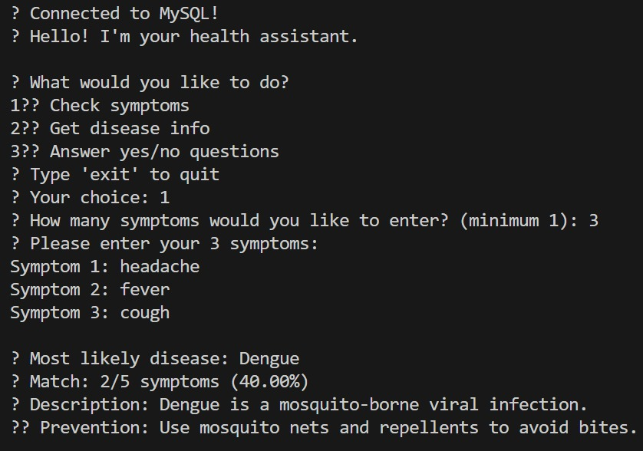

FIGURE A2.1 CONSOLE OUTPUT 1
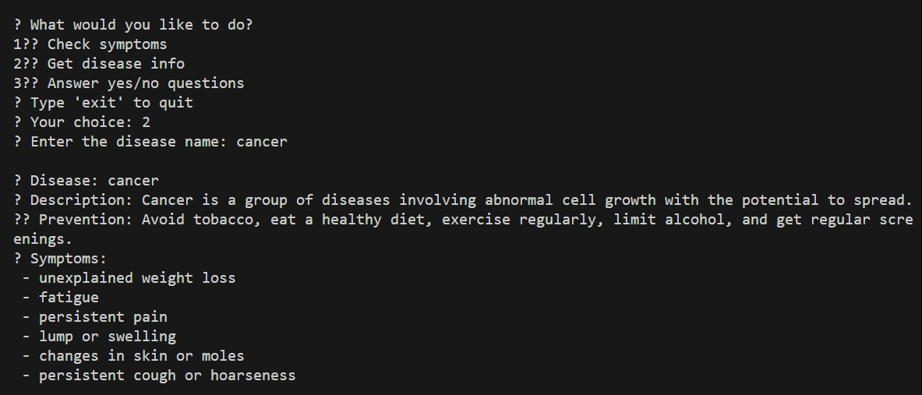

FIGURE A2.2 CONSOLE OUTPUT 2

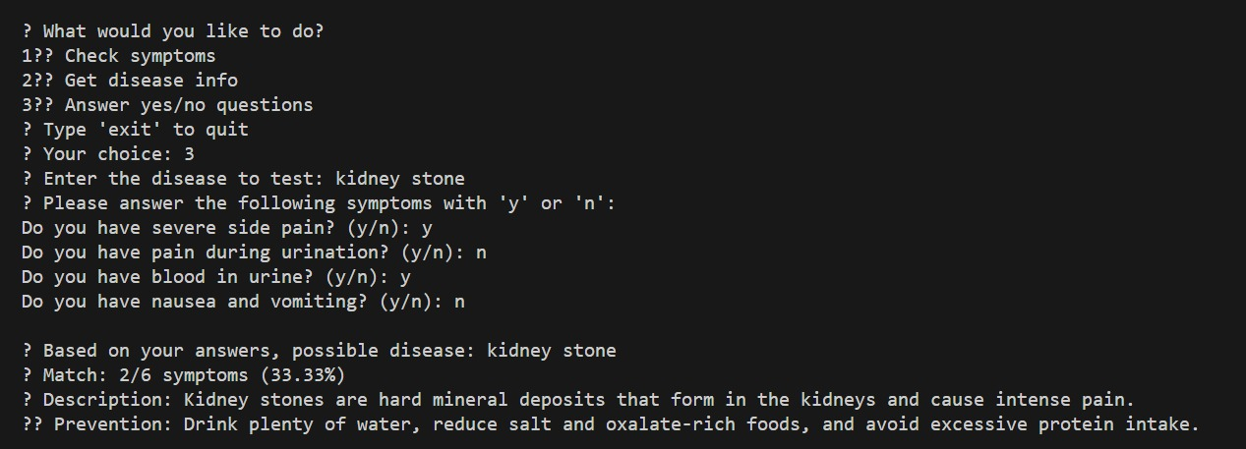

FIGURE A2.3 CONSOLE OUTPUT 3
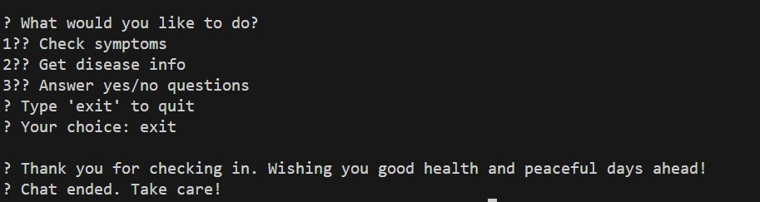

FIGURE A2.4 CONSOLE OUTPUT 4

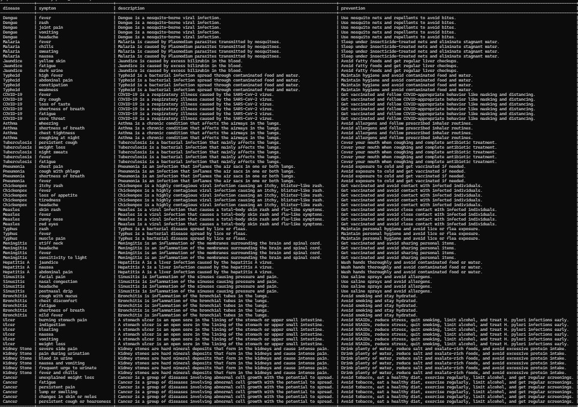

FIGURE A2.5 DATABASE

REFERENCES

Oracle Java Documentation –
Oracle. “Java Platform, Standard Edition Documentation.”
https://docs.oracle.com/javase.
GeeksforGeeks – Data Structures in Java –
GeeksforGeeks. “Data Structures in Java – Overview and Implementation.”
https://www.geeksforgeeks.org/data-structures-in-java/

World Health Organization (WHO) –
WHO. “Health Topics and Disease Prevention Information.”
https://www.who.int/health-topics

Oracle Corporation. (2023). MySQL 8.0 Reference Manual. Retrieved from https://dev.mysql.com/doc/

SDG GOAL – 3. “ GOOD HEALTH AND WELL-BEING”

The Smart Health ChatBot directly supports SDG 3 by promoting early detection and awareness of health conditions. By asking users a series of symptom-based questions and matching their responses with known diseases, the chatbot encourages individuals to reflect on their health and seek medical attention if needed. This proactive approach helps reduce the burden on healthcare systems by guiding users toward preventive care and minimizing unnecessary hospital visits. It also empowers users with basic health knowledge, especially in areas where access to healthcare professionals may be limited.
Additionally, the chatbot serves as a digital health education tool. It provides users with descriptions of diseases and their symptoms, helping them understand potential health risks in a simple, accessible format. This contributes to improved health literacy, which is a key component of long-term well-being. By making health information available to anyone with a computer, the project helps bridge gaps in access and supports the global goal of ensuring healthy lives for all.

